**Potential Motors Coding Challenge**

A more detailed explanation is available at: <https://github.com/Kamran14/Potential/blob/main/README.md>

**Console Output:**

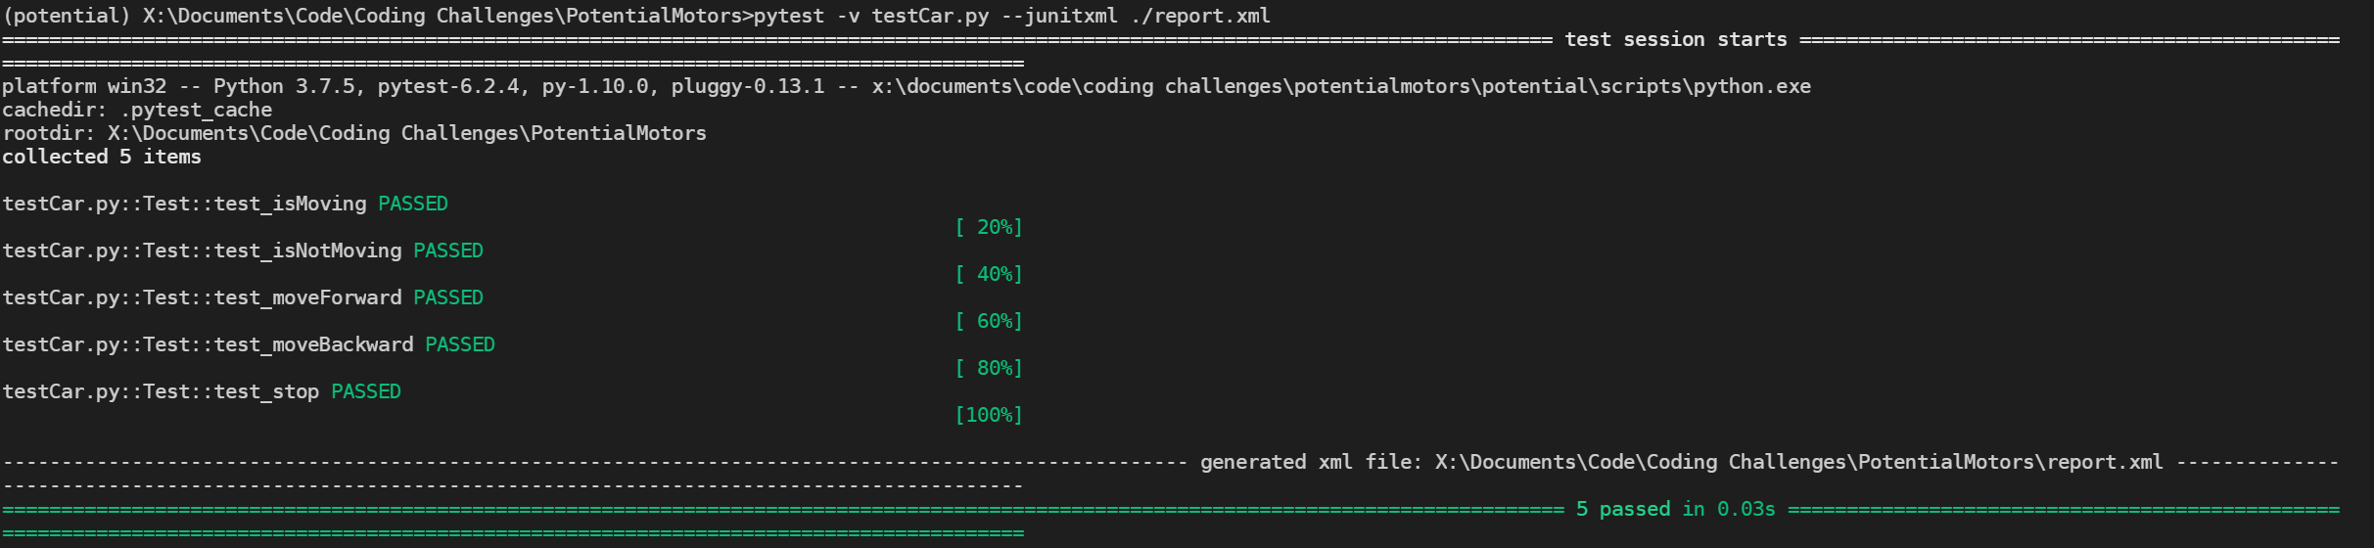

**Jenkins:**

